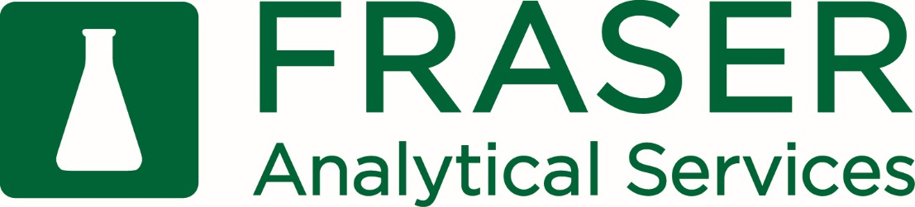

Water Sampling Instructions

- Sample Containers:
A small, 100ml sterile bottle with powder (sodium thiosulfate) is to be used for coliform and E. coli bacteria evaluation.

- Sampling Tap Water:
When sampling for Total coliform/E. coli bacteria, use the 100ml sterile bottle containing sodium thiosulfate (used to remove residual chlorine). Do not rinse bottle prior to collection because this will remove the sodium thiosulfate. These are sterile, sealed containers. To avoid contamination, do not touch the inside of the bottle, cap, or threads.
- Sample from the cold water faucet
- Remove the screen and aerator and run cold water for 2-3 minutes
- Fill the sample bottle. The 100ml bottle should be filled just above the 100ml line
- Tighten the lid completely to avoid spillage during shipping
- Fill out water sample submittal form and write time and date of collection on the bottles

Samples need to be received within 24 hours of collection for Coliform/E.coli bacterial testing. Do NOT freeze samples. If possible, refrigerate samples prior to shipping and keep them at a temperature of 4°C during shipment.
Make sure to package water bottles so that there is adequate cushioning to prevent breakage during shipment.

- Labeling for Analysis
Please write the Farm Name, Time of Sampling, and Date on the bottle.
Download the Water Sample Submittal form here and fill out completely.
- Ship or Deliver samples to:
Fraser Analytical Services
1356 Sumas Way
Abbotsford, BC V2S 8H2

