# How To Submit a Sample on Forage Lab

1. Navigate to <https://clients.foragelab.com/Login.aspx>
2. Enter your Username email and Password

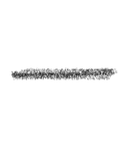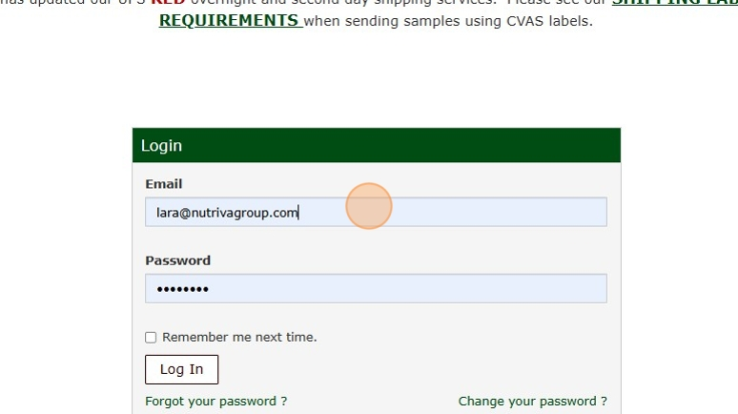

1. Click tab "Sample Submission"

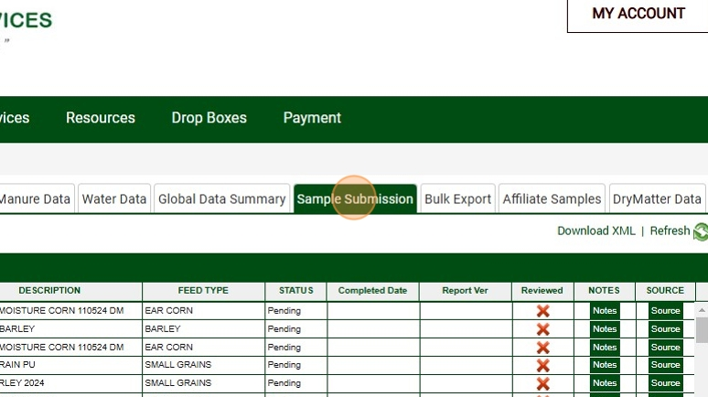

1. Select the "Account" option. Select your account number.

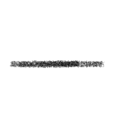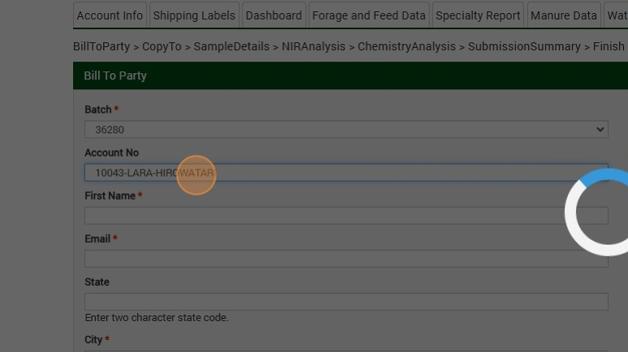

1. Click Continue

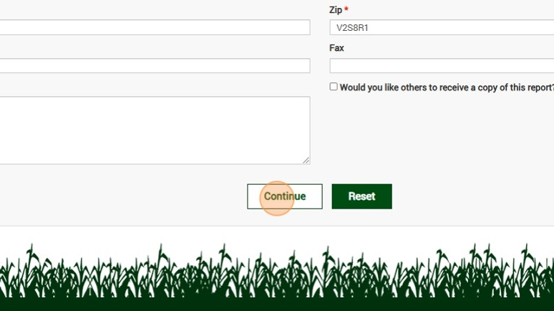

1. Enter the Farm Name

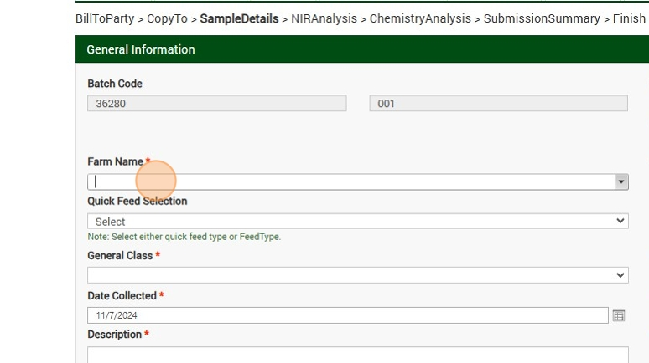

1. Select the feed type

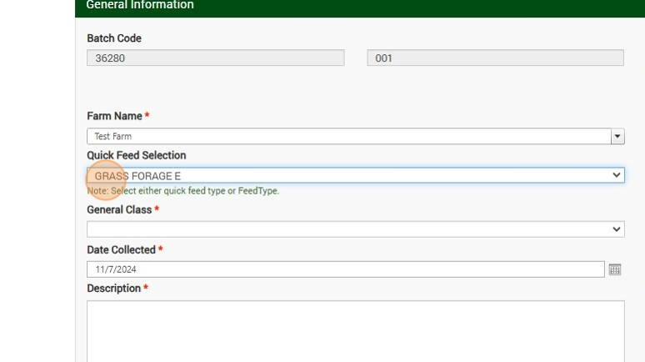

1. Enter a description

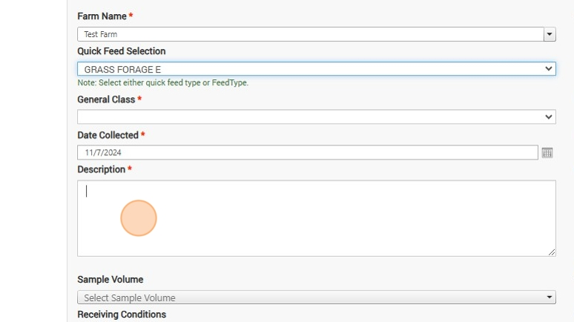

1. Select either NIR Analysis or Chemistry Analysis

1. Select your analysis

1. Submit

1. Review and Submit

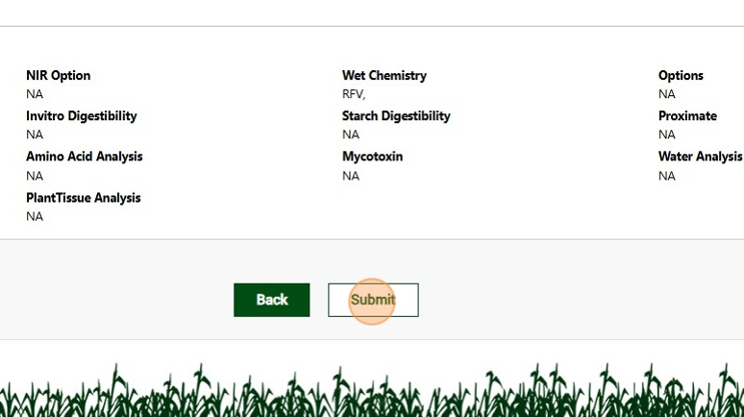

1. WRITE THE BAG # ON YOUR BAG CLEARLY

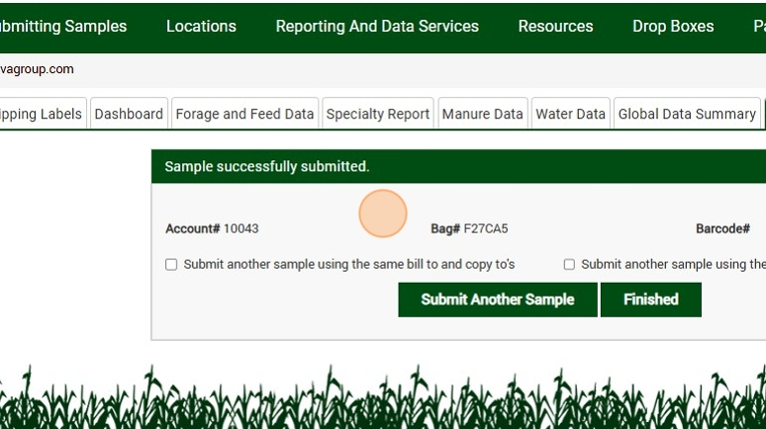

1. You may submit another sample with a. The same account number and copy to and b. the same analysis at this time.

